## **Objectives**

* List the features of ES6

Modern JavaScript features like let and const for block-scoped variables, arrow functions for concise syntax, template literals for string formatting, default parameters, spread/rest operators, destructuring assignment, classes for OOP, modules (import/export), and new data structures like Set and Map were all introduced by ECMAScript 6 (ES6).

* Explain JavaScript let

JavaScript's let keyword declares variables that are block-scoped, which means they can only be accessed within the block {} in which they are defined. It permits value reassignment but prohibits redeclaration within the same scope.

* Identify the differences between var and let

Var and let differ in that var can be redeclared, is hoisted with undefined initialization, and is function-scoped or globally scoped. There is a "temporal dead zone" until it is declared since let is block-scoped, cannot be redeclared in the same scope, and is raised without initialization.

* Explain JavaScript const

This keyword creates block-scoped variables that, once initialized, cannot have their references changed. The contents of the objects or arrays that the reference points to can still be changed even though the reference itself is constant.

* Explain ES6 class fundamentals

ES6 classes offer a more streamlined syntax for defining methods and constructing objects. A class can have more than one method without the function keyword, is defined with the class keyword, and has a constructor method for initializing objects.

* Explain ES6 class inheritance

ES6 enables classes to use the extends keyword to inherit methods and properties from another class. To call the parent class constructor and access its methods or properties, the subclass constructor uses the super() method.

* Define ES6 arrow functions

Arrow functions use the => symbol and offer a simple syntax for writing functions. They are perfect for callbacks where this should refer to the surrounding scope because they don't have their own this, arguments, or prototype.

* Identify set(), map()

A set is a group of distinct values with duplicates automatically eliminated. A map is a key-value collection that accepts keys of any kind while maintaining insertion order. Both have built-in methods for adding, removing, and checking values, and they are both iterable.

Create a React Application named “cricketapp” with the following components:

1. ListofPlayers

* Declare an array with 11 players and store details of their names and scores using the map feature of ES6
* Filter the players with scores below 70 using arrow functions of ES6.

1. IndianPlayers
   1. Display the Odd Team Player and Even Team players using the Destructuring features of ES6
   2. Declare two arrays T20players and RanjiTrophy players and merge the two arrays and display them using the Merge feature of ES6

Display these two components in the same home page using a simple if else in the flag variable.

**OUTPUT:**

When Flag=true

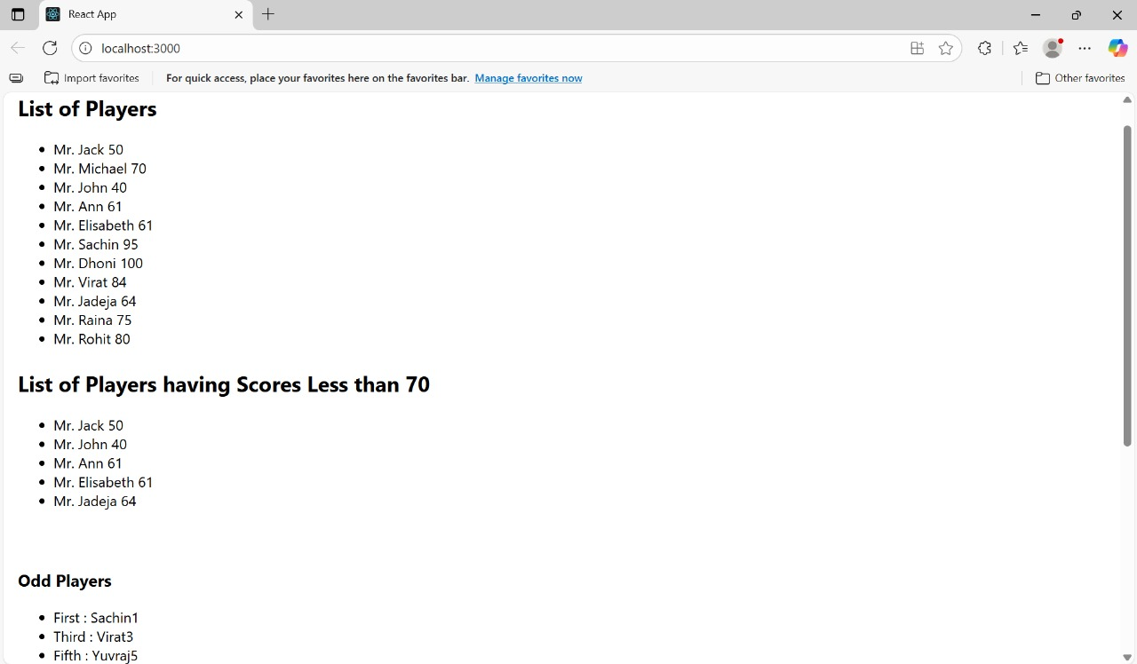



When Flag=false

